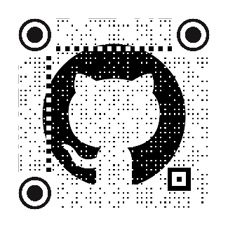Tandem 16   
Badge Building Instructions

# Overview

The Tandem Badge project is a project that allows building and customization of a convention badge that can be worn at trade shows. The idea is a spin of the [DefCon badges](https://defcon.org/html/links/dc-badge.html), and it leverages the [SAO](https://hackaday.com/2019/03/20/introducing-the-shitty-add-on-v1-69bis-standard/#:~:text=In%202017,%20there%20was%20an%20obvious%20need%20for%20a%20standard) interface as described in the [DefCon](https://defcon.org/html/links/dc-badge.html) sites.

The badge is a 2-layer design that has the main electronics on the lower board with a top cosmetic PCB that covers the electronics. A paper white display provides a persistent name badge and is also the microcontroller for the electronics. The device is designed as a tribute to the original Tandem computer panel created in 1975-76 and used until the three production Tandem systems prior to the release of the VLX (T16 (aka TNS-I) TNS-II, and TXP). The panel on these is shown below. It has two LEDs that were used for displaying “power” and “run” (TNS-II and TXP only), and 16 more LEDs placed in a row to the right, next to the two other LEDs. The 16 LEDs were framed with a silkscreen to break the 16 bits into Octal values (groups of 3) with a single remaining LED to the left of the groups of 16. The silk numbers the bits in order from 0 (leftmost) to 15 (rightmost). Octal values are entered as big endian (e.g. %42 = 0 000 000 000 100 010).

Figure - T-16 / TNS-1 switch panel

Under the row of LEDs there are switches that set and reset the LEDs (in the real computer panel they also set/reset the registers in the computer).

For each switch, there is a corresponding LED above it. Individual switches can be set to any value.

The badge simulates the behavior of this design. It uses a “register” value to hold the current switch configuration. In some cases, the value of the switches causes special actions. These special switch values are documented elsewhere in the operation instructions on [Github](https://github.com/AntiqueSounds/Tandem-Badge) (see above QR code).

# The Tools required to build the badge

The electronics are placed using through-the-hole components. There are no surface-mount parts in this design. Soldering should be simple, even for beginning skills level soldering.

* Soldering iron and solder
* Ethyl cyanoacrylate “Crazy” glue (GELL stye greatly recommended)
* Small screwdriver (usually using a phillips screw)
* Pliers to hold the small nuts.

# Parts List

* 3D Printed parts (as part of the kit need to be printed prior to the build)
  + DIP switch extensions (16)
  + Display cover (optional shroud over the display to make it nicer)
  + Simulated reset key
* 3MM offset spacers 5MM long (4)
* 3MM offset spacers 3MM long (4)
* M3 Screws (4)
* M3 Nuts (4)
* Extended 2x3 female headers (2)
* 13 pin female headers (2)
* 13 pin extended (long) male headers (2)
* 9 pin resistor array (8 - 10k resistors) (2)
* 9 pin resistor array (8 - 470 resistors) (2)
* Small standard (3MM) LEDs (amber or yellow) (16)
* Small standard (3MM) LEDs (red) (2)
* Small standard (3MM) LED (green) (1)
* 3 switch DIP (MUST BE OFFSET, NOT STANDARD DIP SWITCH!) (5)
* 1 switch DIP (MUST BE OFFSET, NOT STANDARD DIP SWITCH!) (1)
* 67 ohm (or near value) resistors (3)
* 74HC165 in DIP configuration (2)
* 74HC595 in DP configuration (2)
* DIP Sockets (16 pins) (4) (recommended but optional)
* Lithium battery 3.3V/4V
* Generic Diode (recommended) or a jumper.
* LilyGo ePaper (paperwhite) T3 display and ESP processor.
  + Software - [Xinyuan-LilyGO/LilyGo-T5-Epaper-Series (github.com)](https://github.com/Xinyuan-LilyGO/LilyGo-T5-Epaper-Series/tree/master)
  + [LILYGO® TTGO T5 V2.3.1_2.13 Inch E-Paper from Lilygo on Tindie](https://www.tindie.com/products/lilygo/lilygo-ttgo-t5-v231_213-inch-e-paper/#product-description) (make sure includes the 9102 chip)

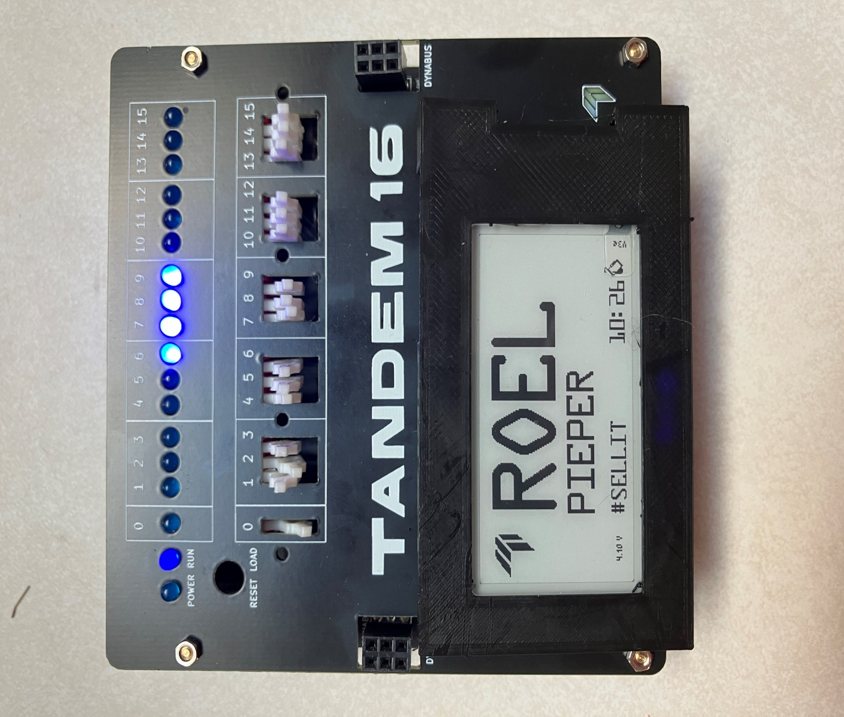

Finished Build. This one was built with blue LEDs as a joke.

### Step 0

Print or obtain the 3D printed items: 1 Key with base, 16 or more white lever extensions, and one display cover/shroud

### Step 1

Place the 5MM spacers onto the main board from the top with the female facing down, Secure the shorter 3MM (or less) spacer using the male side through the hole to hold the top/longer spacer onto the main board. Repeat for each corner of the main board. In the end, you should have all 4 spacers placed with the short spacer on the bottom and the longer spacer on the top.

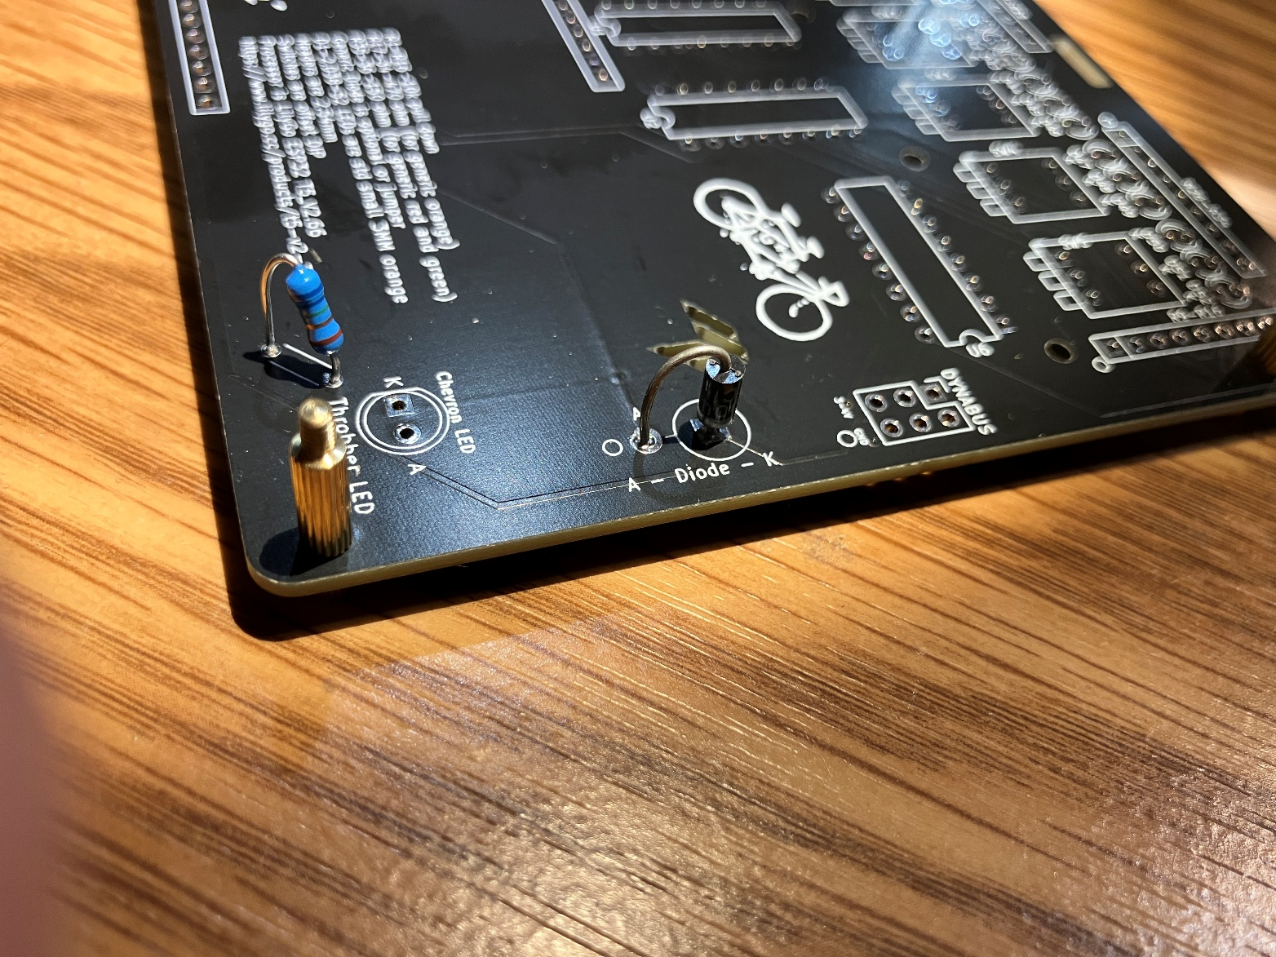

Figure - Board with spacers placed

### Step 2

Place one of the three (~67 ohm) resistors into the resistor component holes. Orientation does not matter. Solder these leads to the board.

Place one of the red LEDs into the Throbber LED component holes. Not orientation. Anode (long leg) on the right, flat side left. DO NOT SOLDER the LED YET!

Figure - lower red LED place loosely

### Step 3

Place the two leftmost top LEDs (red and green) into the D1 and D2 holes. MAKE SURE the ANODE is toward the lower side of the board and the cathode is toward the top edge of the board. Early versions of the board silkscreen have the A/K reversed. K should be on the top, and A on the bottom (with the flat side being the K at the TOP). This orientation is the same for ALL of the LEDS at the top of the badge.

Once the red and green LEDs are placed, place all of the remaining 16 yellow or orange LEDs into the remaining LED holes. Orientation should be the same for all LEDs. Flat side of the LED up toward the top of the board. Long lead toward the lower side of the board.

Step 4

Pick up the lower board and let the LEDs slide and rest onto the lower board (freely) Same for the remaining red LED that sits on the lower right side of the main lower board.

Figure - LEDs placed loosely into the holes

Rest the top board over the spacers of the bottom board. Install 2 to 4 screws to hold the top board onto the lower board. Then flip the entire badge over (both boards upside down). Guide each of the loose LEDs into the corresponding hole in the top board. Make each one fit directly into a hole and seat down all the way to the LED stopper. LEDs should all fit perfectly into each hole before proceeding. Check that ALL of the LED pins are aligned the same and that they are correctly placed before soldering.

Check the remaining red LED in the lower corner of the badge. Make sure it is resting with the tip on the little chevron on the top board. The LED should not be bent and should rest on the chevron before soldering.

Solder all LED connections. Double and triple check orientation before clipping the remaining wire short.

